# CHAPTER I INTRODUCTION

## Overview of Court Case Management

The court case management software is used to add case and hire advocate for that case online. This software is request advocate to handle our case once the advocate accepted our case this app will be alert petitioner/respondent about the advocate acceptance. And this app is also having a facility to transfer money online to advocate and generate invoice for each transaction with GST. The court case management software will have a cloud storage to store case evidence and important case documents those document is being encrypted using AES encryption algorithm. Here a chat app is available that will help advocate and petitioner to communicate more case details. This app is also having consultation part that will help petitioner/respondent to consult about case details before adding case and consult general law rules and regulations

## Definition

The CCM (Court case management) System is used add case and hire advocate for that case in online. This app will store case documents and case evidence

# CHAPTER II FEASIBILITY STUDY

## Proposed Work

The proposed software product is The court case management software is used to add case and hire advocate for that case online. This software is request advocate to handle our case once the advocate accepted our case this app will be alert petitioner/respondent about the advocate acceptance. And this app is also having a facility to transfer money online to advocate and generate invoice for each transaction with GST. The court case management software will have a cloud storage to store case evidence and important case documents those document is being encrypted using AES encryption algorithm. Here a chat app is available that will help advocate and petitioner to communicate more case details. This app is also having consultation part that will help petitioner/respondent to consult about case details before adding case and consult general law rules and regulations

.

## Advantage

* + - * File remains secure both on cloud and during transmission.
      * The app is transfer money online
      * This app will generate Invoice
      * Easy to Add Case
      * Easy to Hire Advocate
      * Consult Advocate Online
      * Get Case Status

## Hardware Requirements

Processor : Core i3/i5/i7 RAM : 2-4 GB

HDD : 500 GB

## Software Requirements:

Platform : Windows 7/8/10

Front End : Xampp, PHP, 000 Webhost Cloud server Back End : MySQL

Software : CryptoFS, MOLE decryptor

# CHAPTER III SYSTEM DESIGN

## 3.1 System Architecture

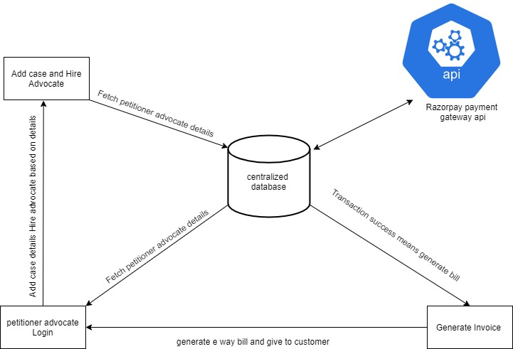

*Fig. 3.1 System Architecture*

The Petitioner/Advocate must register in this application after which they will get OTP confirmation. Once login successfully petitioner can add the case details and hire Advocate.The Advocate will submit case details to the court (offline). Then Advocate has to enter CNR number ,court order and next hearing date after receiving those details from court. The Advocate will request to the petitioner regarding payment details. Then the system will show the transaction alert in petitioner dashboard . Once petitioner click pay now button the page is redirected to transaction process. If the transaction is success then the application shows invoice to petitioner and also have facility to print invoice.

## 3.1.1 Use Case

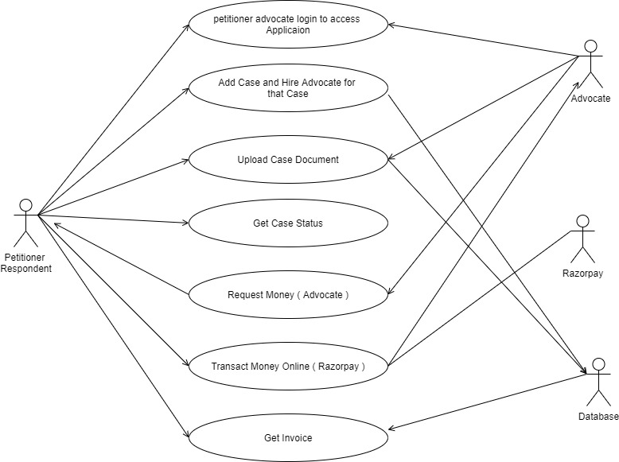

*Fig. 3.2 Use case diagram for court case management software*

# CHAPTER IV

**CONCLUSION AND FUTURE ENHANCEMENT**

## Conclusion

In this paper I have provided add case and hire advocate for that case and transfer money online to the advocate

## .Future Enhancement

In future, this technique can be implemented in audio and video files. Reverse hacking may be implemented in case of intruder’s attack where the intruder receives only the virus content of the file. Selection of file sequence can be processed in advance using different method

# APPENDICES APPENDIX I





*Fig.A1.1 Home Page*

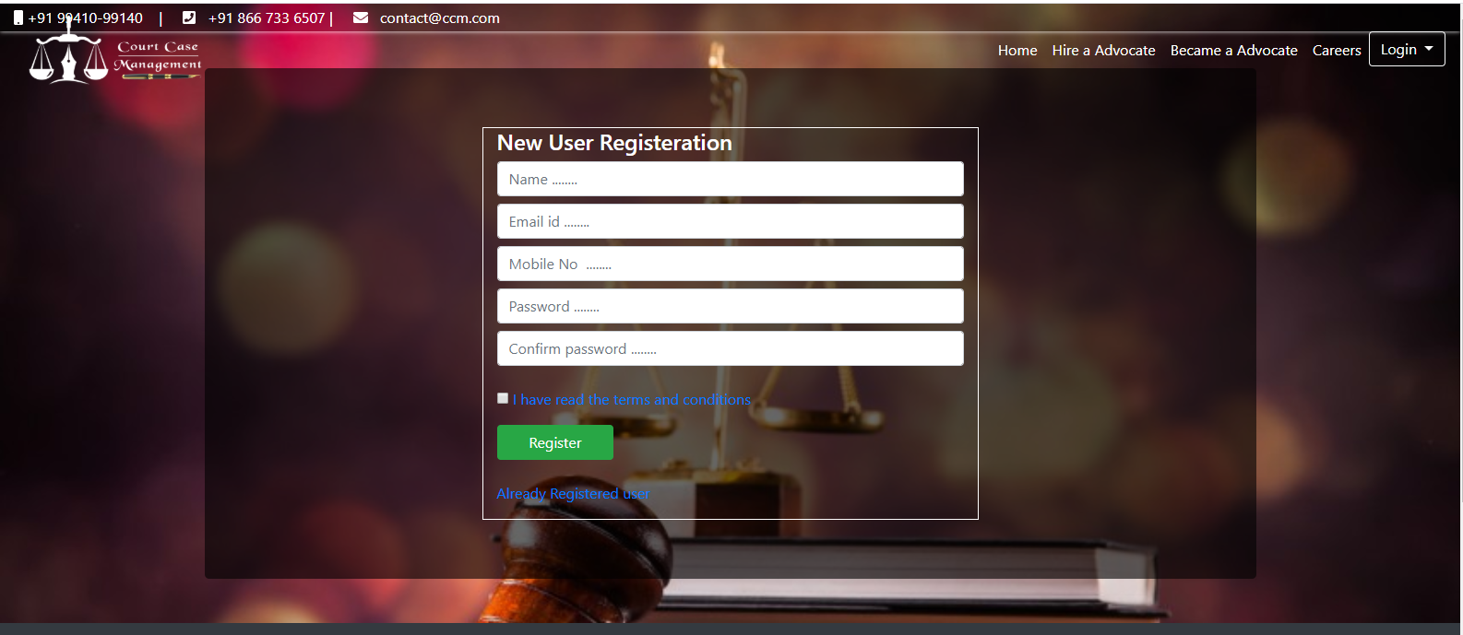

*Fig.A1.1 New Petitioner Registration*

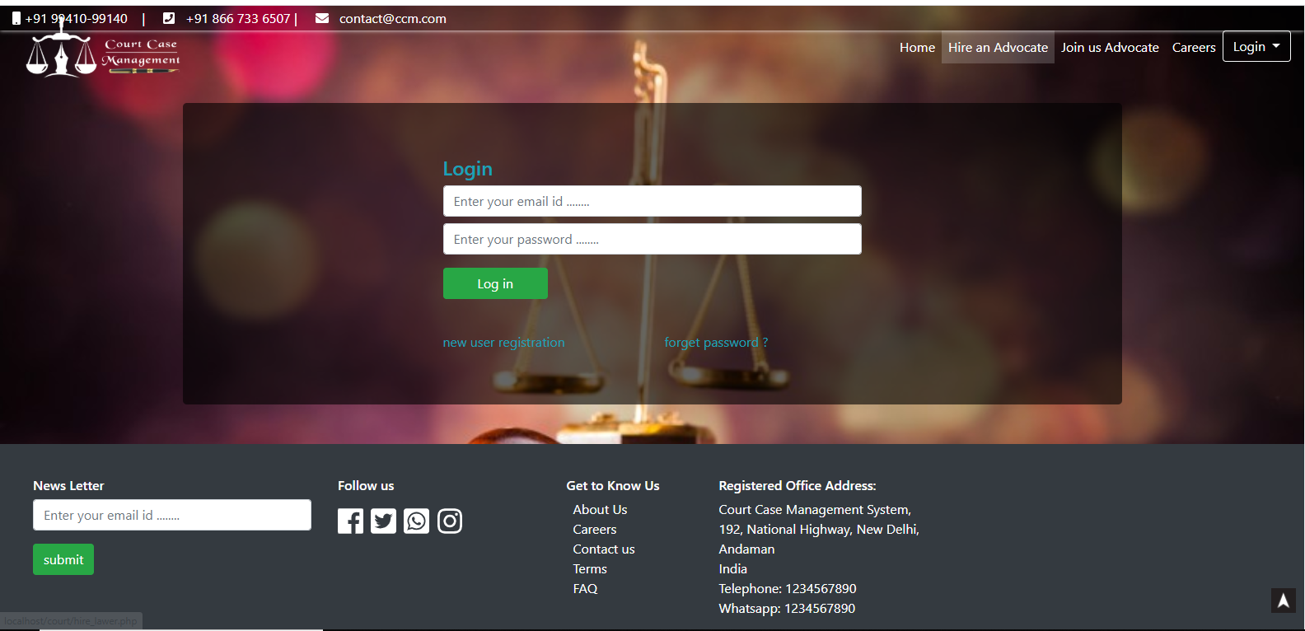

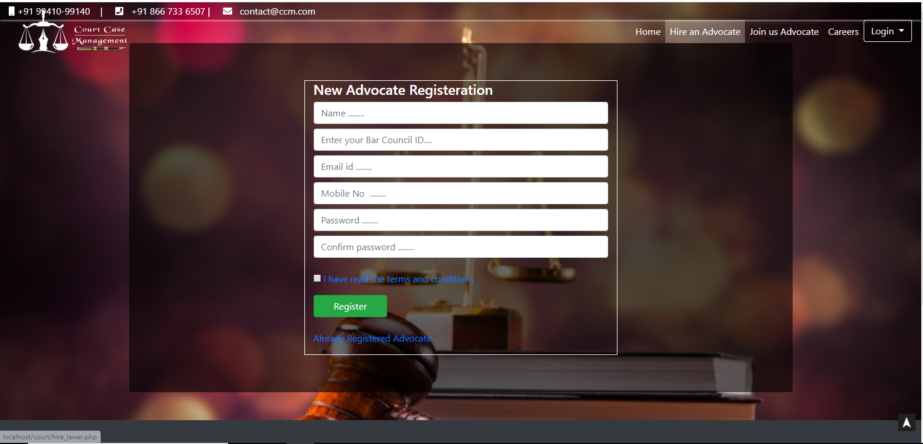

*Fig.A1.1 New Advocate Registration*

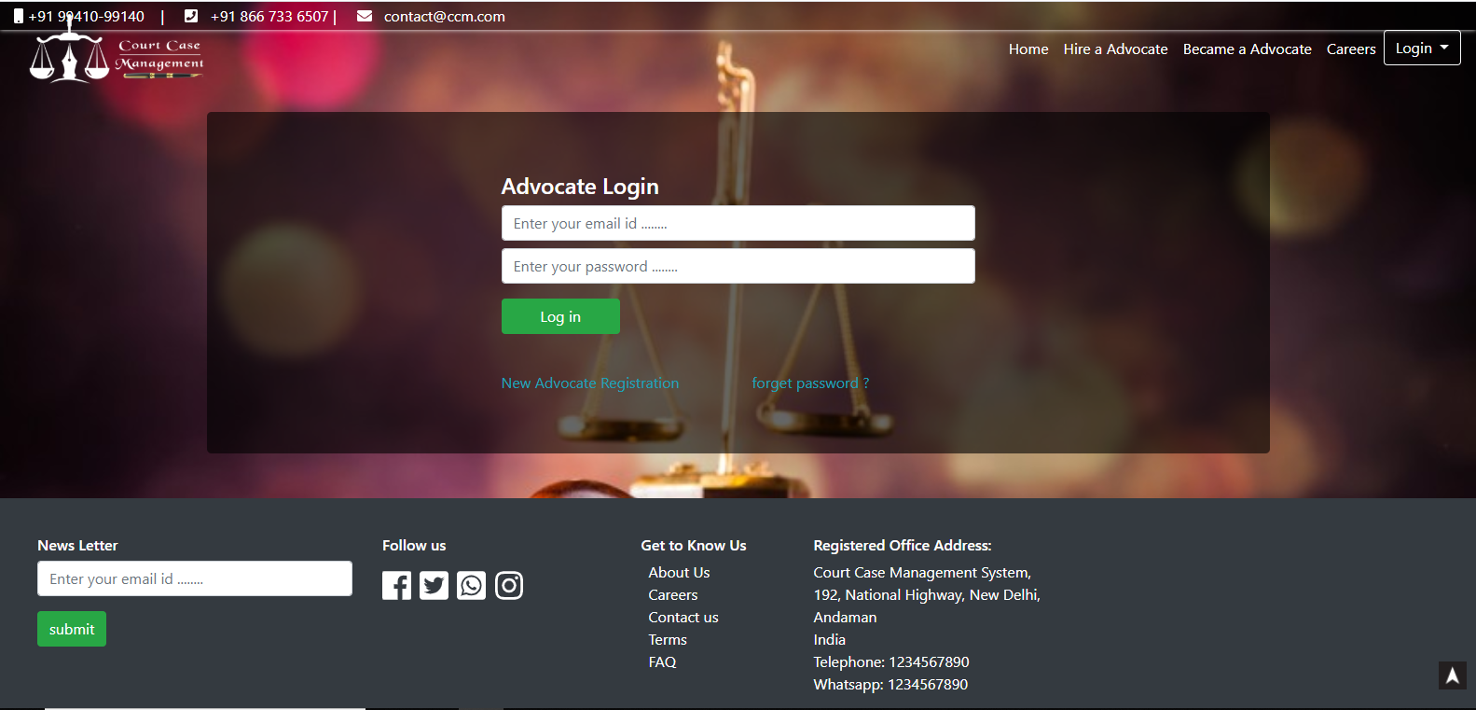

*Fig.A1.2 Advocate Login*

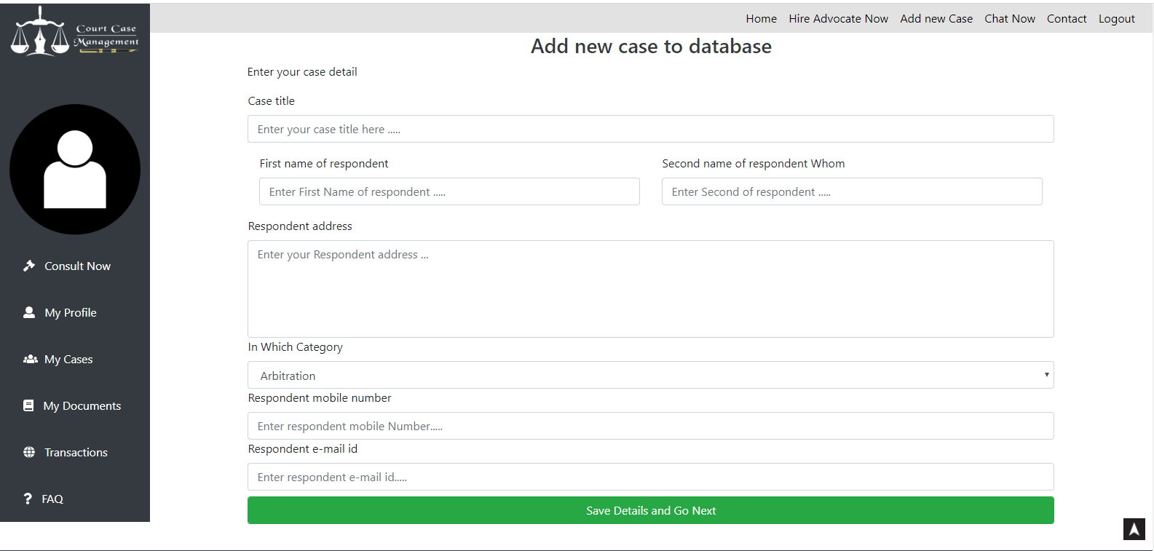

*Fig.A1.3 Add cate*

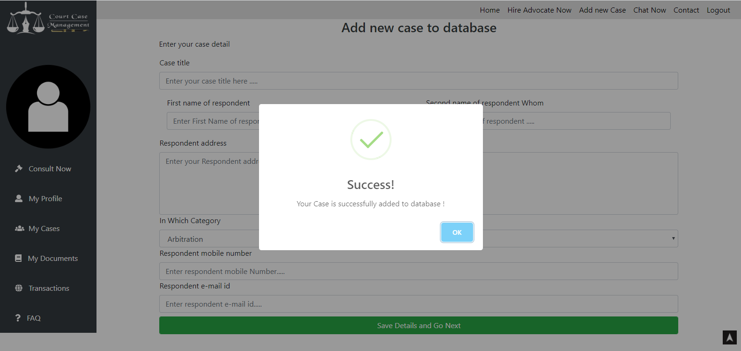

*Fig.A1.4 Case stored in database*

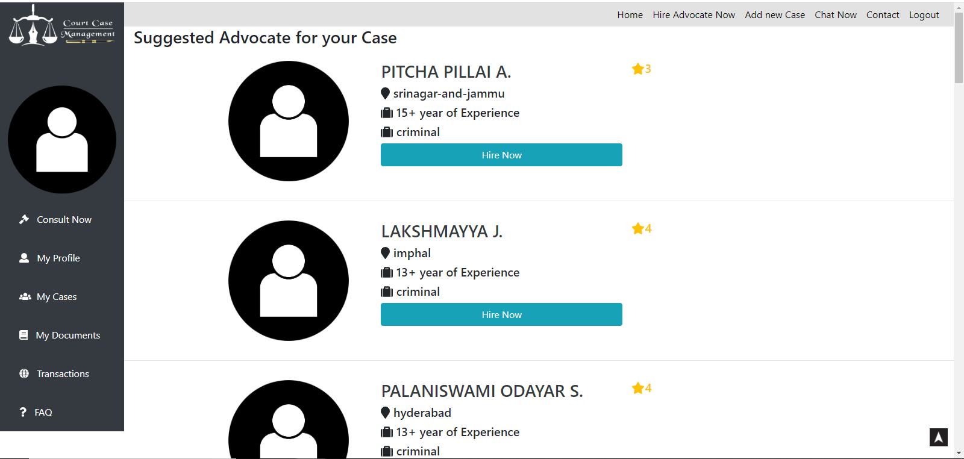

*Fig.A1.5 Advocate Recommendation based on case detail*

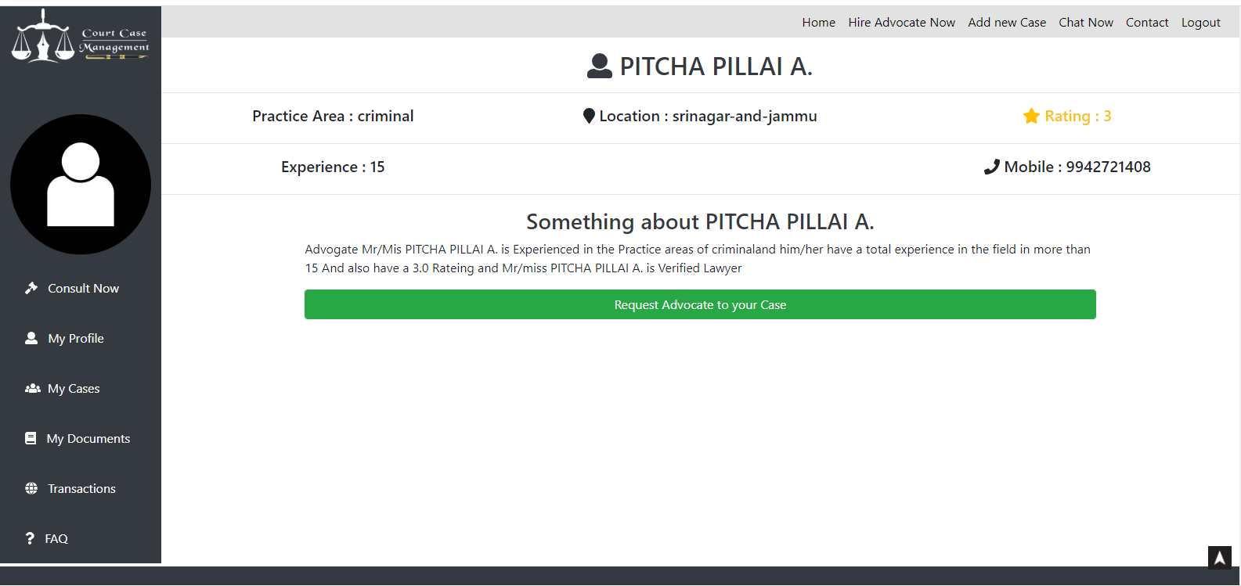

*Fig.A1.6 Advocate Full detail*

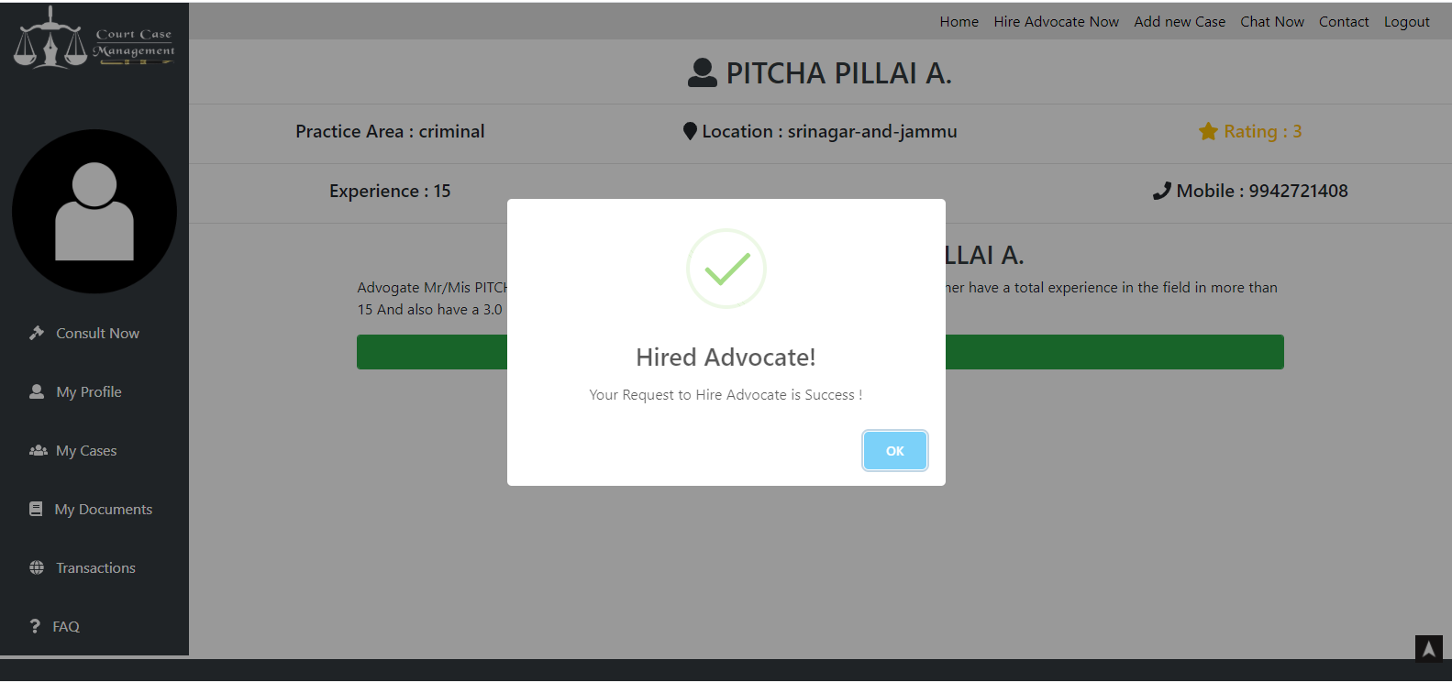

*Fig.A1.7 Request advocate to Handle case*

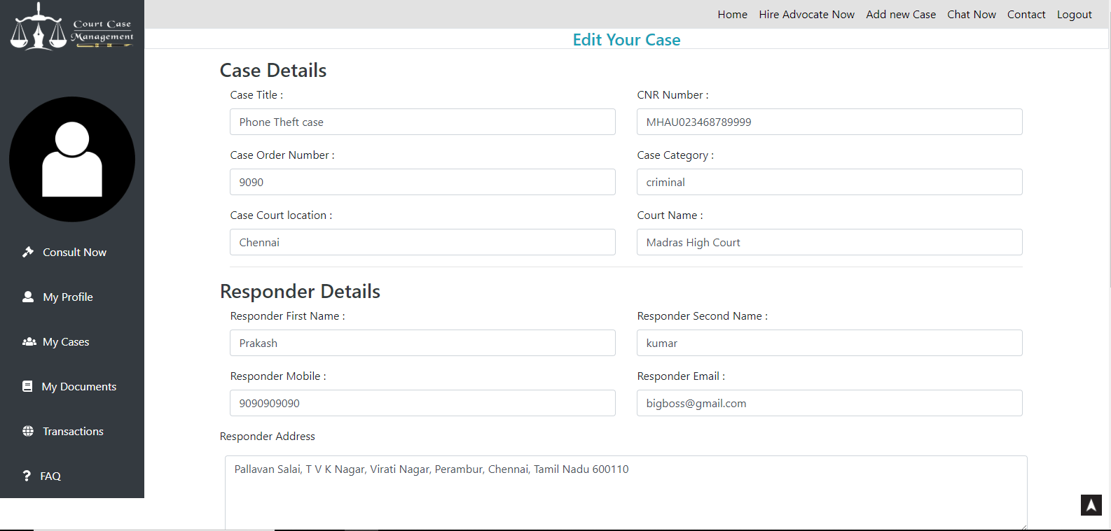

*Fig.A1.8 Case Details Update*

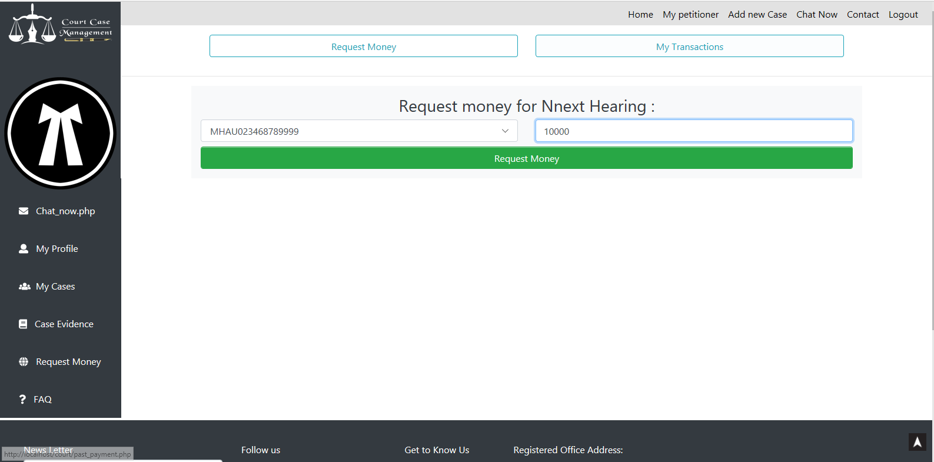

*Fig.A1.9 Request Money*

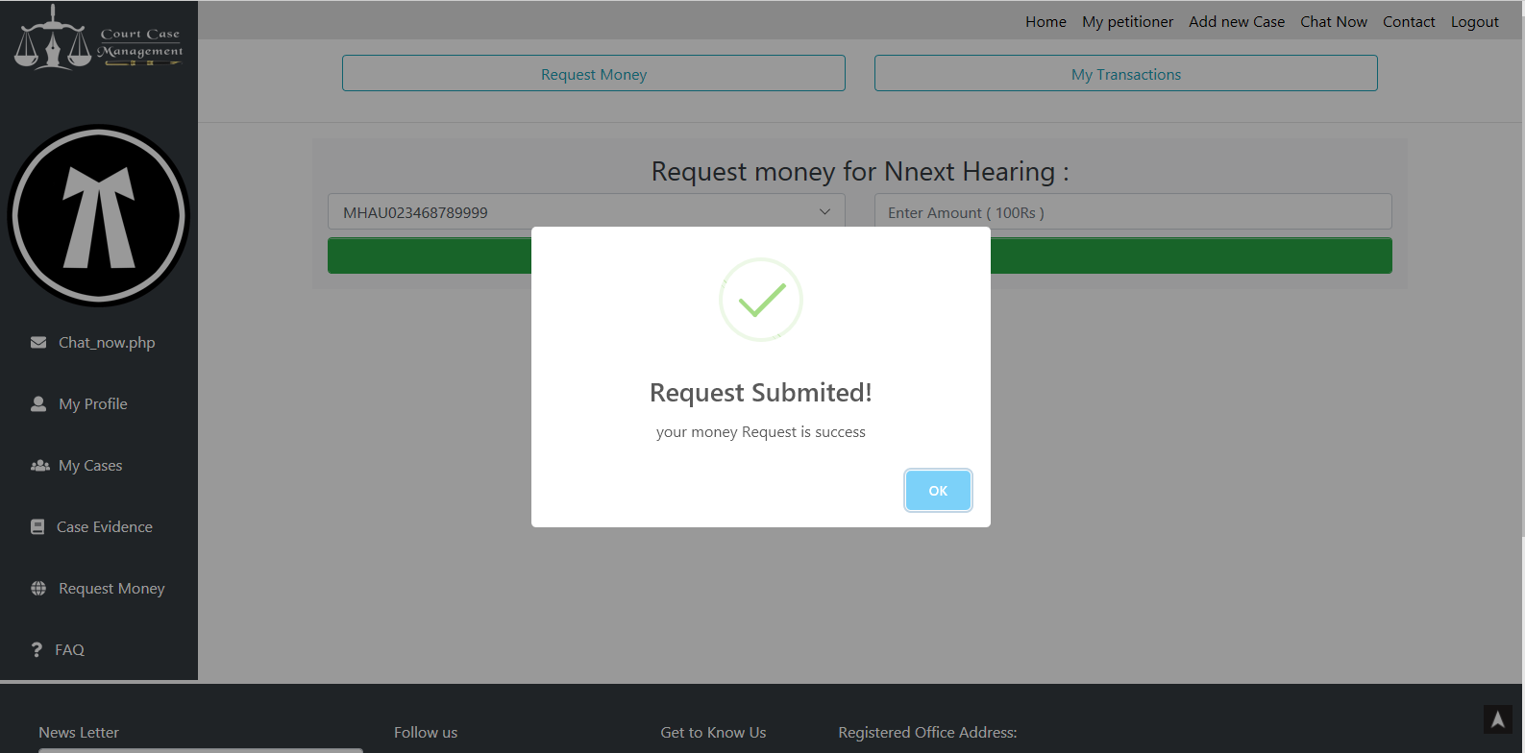

*Fig.A1.10 Request Success Alert*

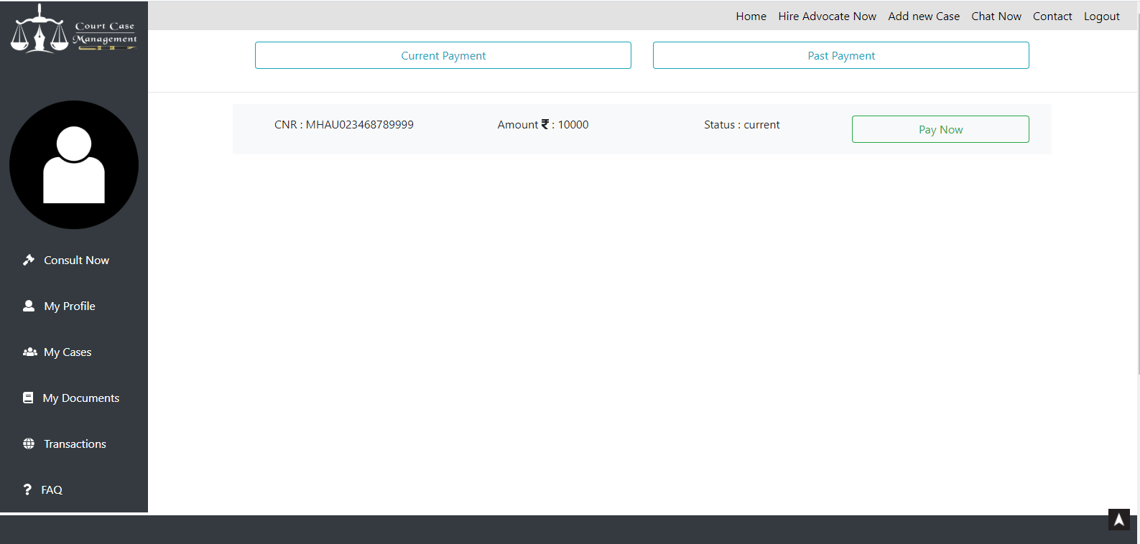

*Fig.A1.11 Money request in Petitioner dashboard*

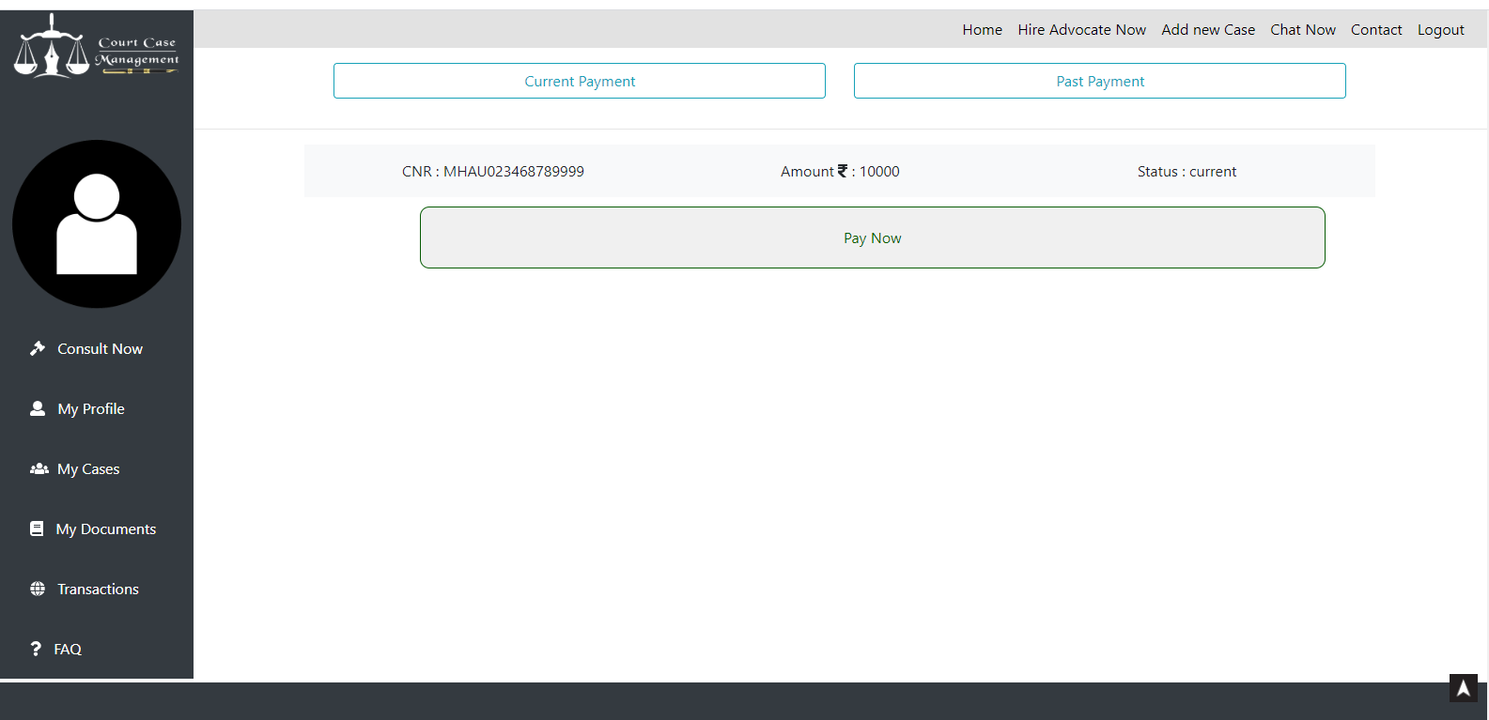

*Fig.A1.12 Money Pay Now button*

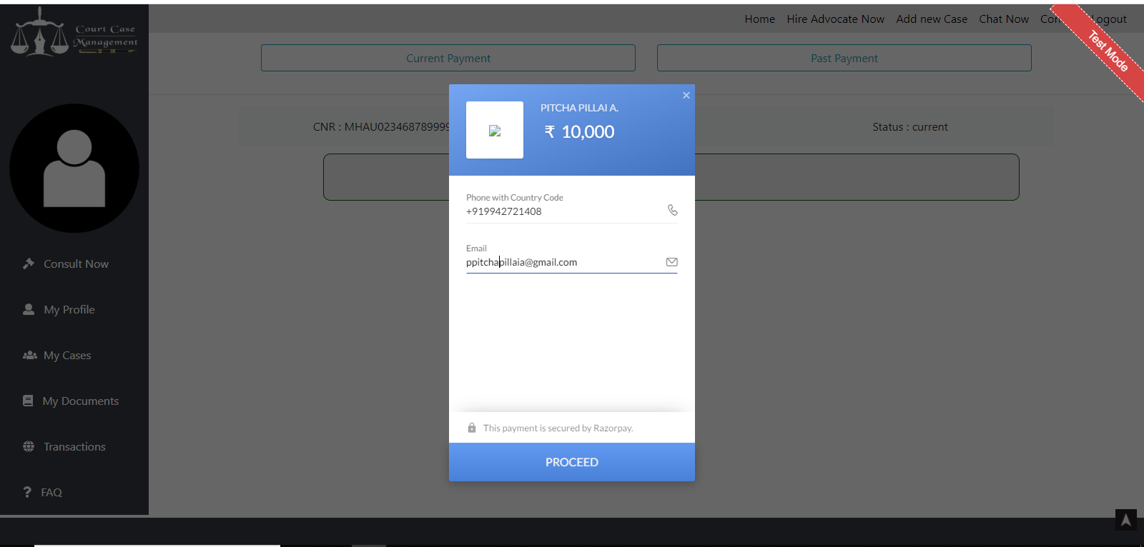

*Fig.A1.13 Razorpay Online Transaction*

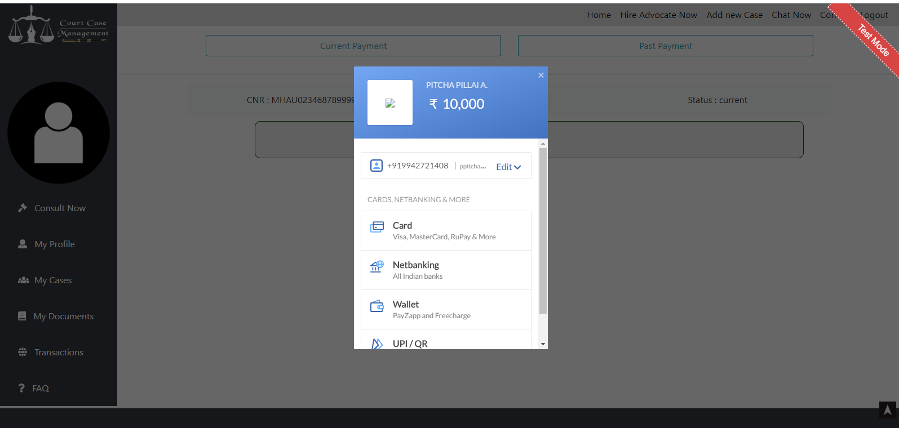

*Fig.A1.14 Selecting transaction type*

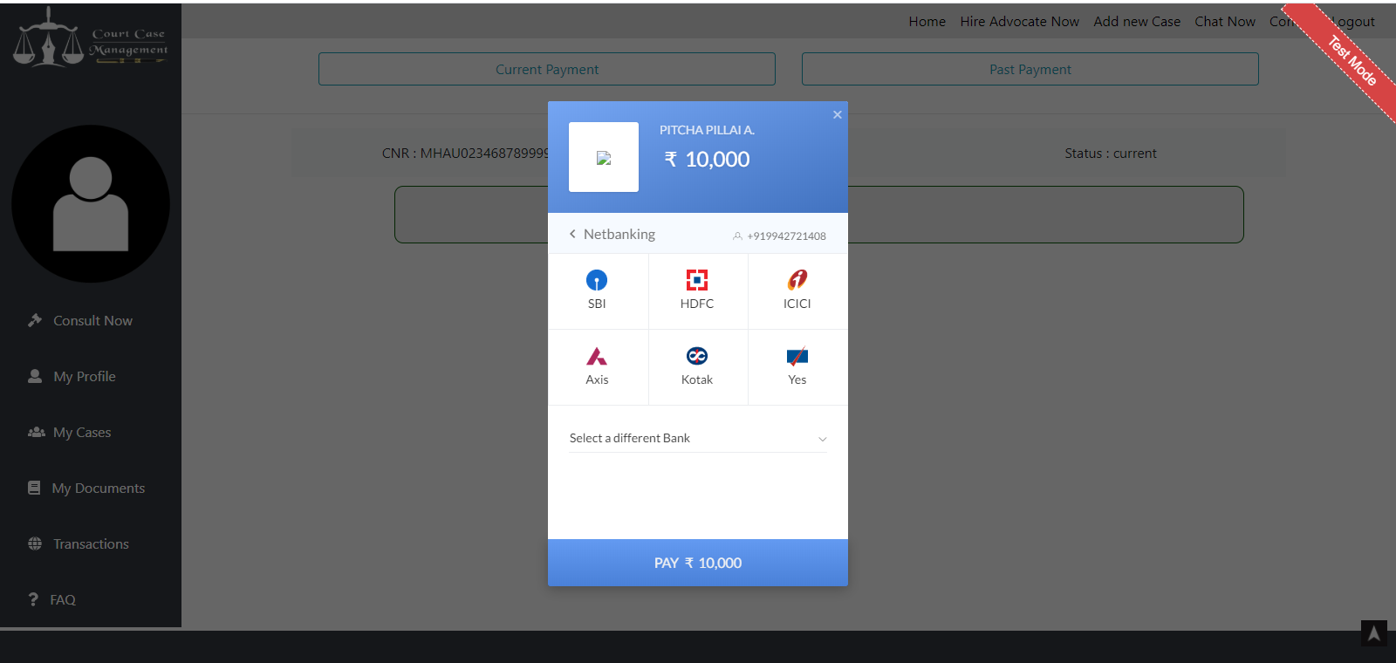

*Fig.A1.15 Net banking Chosen*

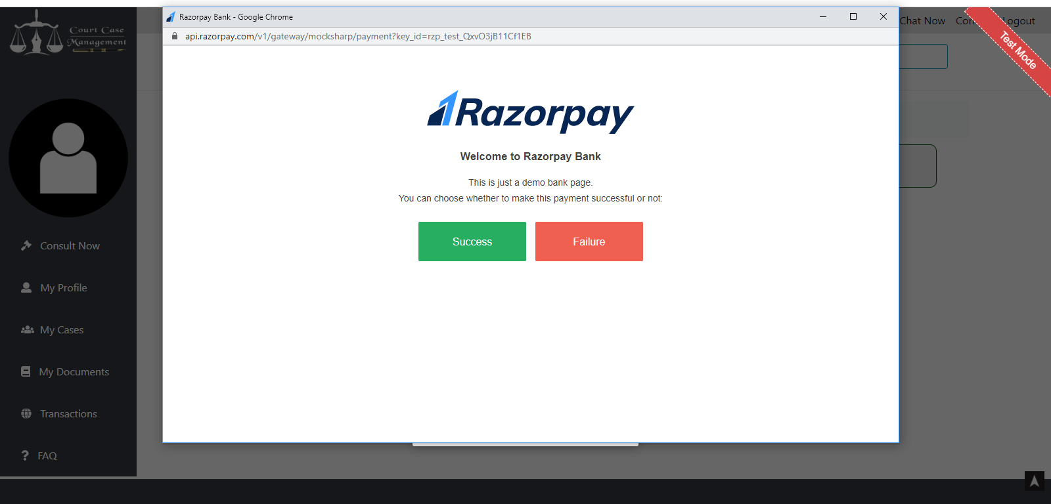

*Fig.A1.16 Transaction Page*

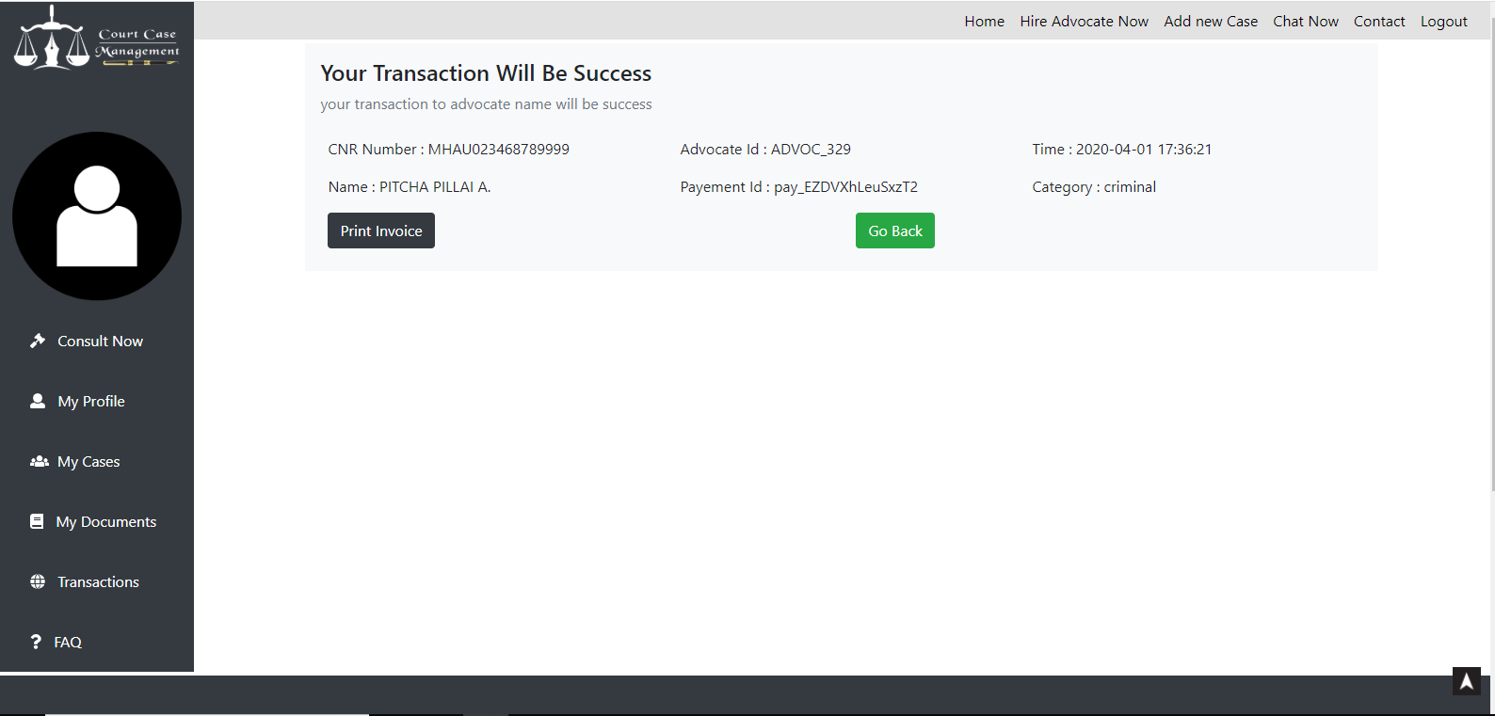

*Fig.A1.17 Transaction success alert*

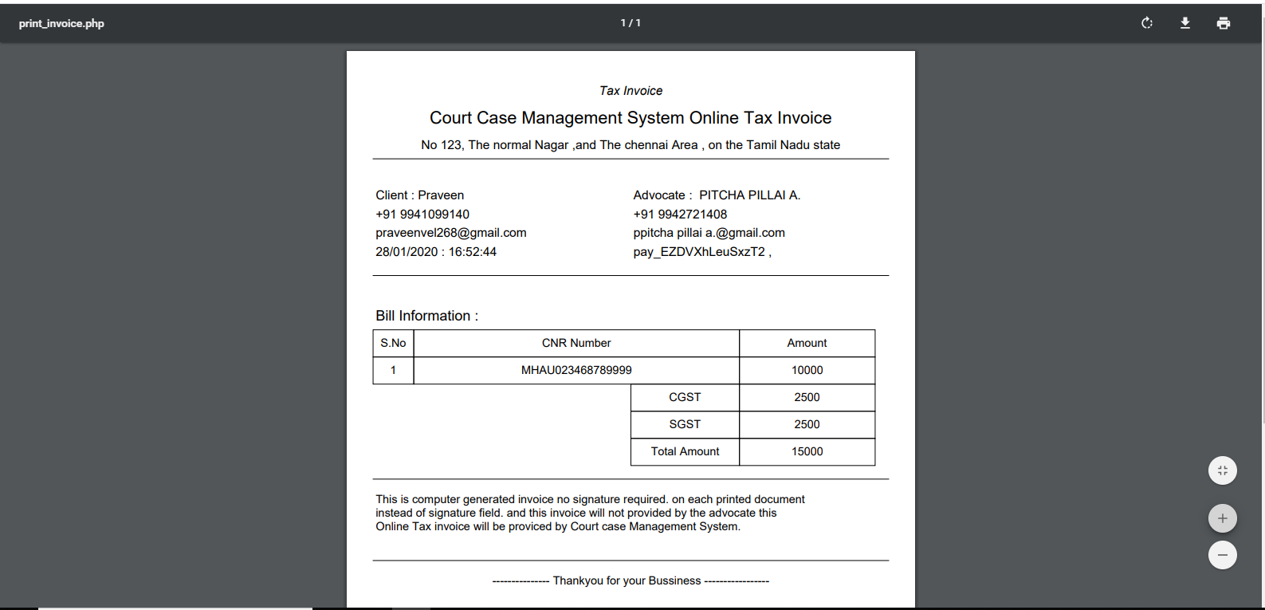

*Fig.A1.18 Invoice is printed*